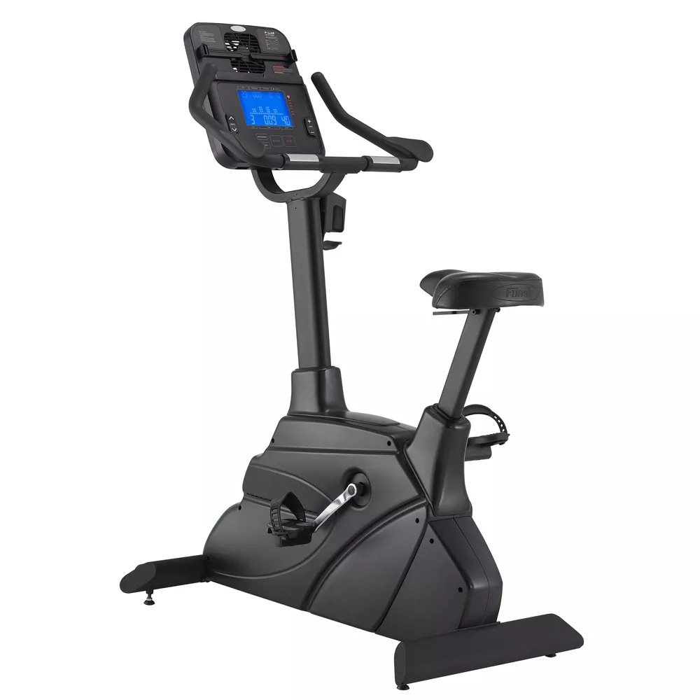

B65
Description & Specifications
The high-quality, well-stitched upholstery with intuitively adjustable devising accommodates exercisers at any height and operates conveniently. A sleek, multi-function console can be equipped with the tablet for engaging your favorite entertainment and controlling the exercise process. Dual elbow pads release compression of the arm to promote workout durability.

- Features: Water bottle holder, Personal workout App
- Console: 7.5" LCD display with LED backlight
- Display Feedback: Time, Distance, RPM, Pulse, Level, Speed, Calories
- Programs: Total programs(8) Manual, Cardio, Fat burn, Interval, Training, HRC, Custom1&2
- Tension Control: Program control
- Resistance Levels: 24
- Resistance System: ECB resistance
- Power Requirements: Self-generated
- Watt: 20~450 Watts (30~90 RPM)
- Pedals: Self-balancing with easy adjust straps
- Fore / Aft Seat Adjustments: N/A
- Transport Wheels: Yes
- Vertical Seat Adjustments: Yes
- Wireless & Contact Grips: Yes
- Max User Weight: 400 lbs. / 180 kg
- Dimensions: 114 × 65 × 151 cm / 45" × 26" × 60"

Fitness Master Inc. 11419 Mathis Avenue #200, Farmers Branch, TX 75234
Office : 214-350-8884 Toll Free: 855-846-0087
Email: admin@fmiamerica.net

Website: www.fmiamerica.com

