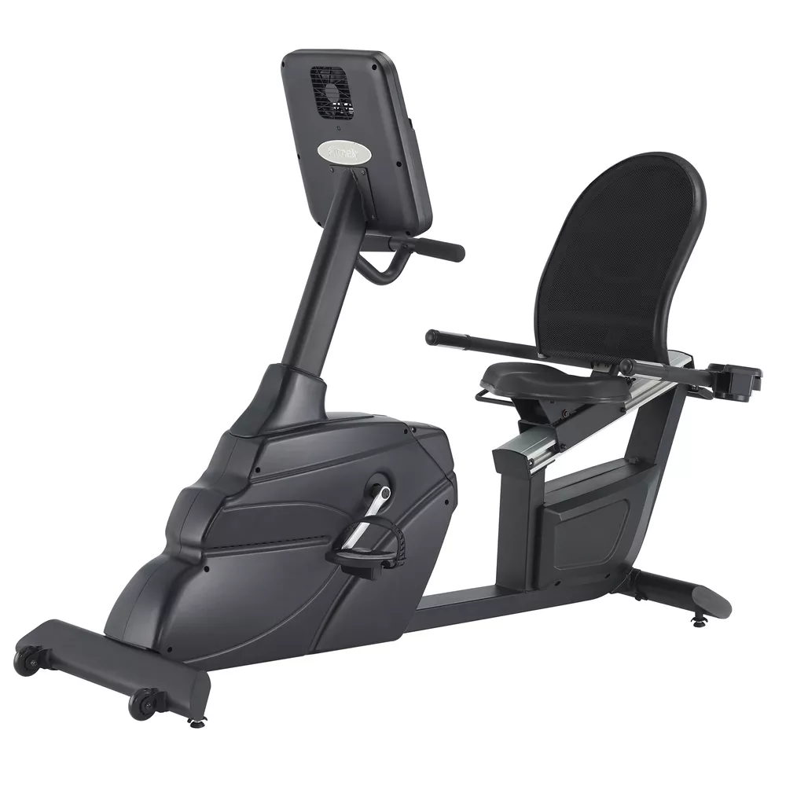

R65
Description & Specifications
The wide, easy-to-access walk through design of R65 allows exercisers to get on and off conveniently. Double beam trajectories of the seat adjustment provide a fluid motion to find the ideal workout position with a comfortable feeling. Bilateral handles with heart-rate sensors ensure stability and assist the operator in measuring their physical conditions. The ventilated backrest offers an optimal comfort and extreme support.

- Features: Water bottle holder, Personal workout App
- Console: 7.5" LCD display with LED backlight
- Display Feedback: Time, Distance, RPM, Pulse, Level, Speed, Calories
- Programs: Total programs (8) Manual, Cardio, Fat burn, Interval, Training, HRC, Custom1&2
- Tension Control: Program control
- Resistance Levels: 24
- Resistance System: ECB resistance
- Power Requirements: Self-generated
- Watt: 20~450 Watts (30~90 RPM)
- Pedals: Self-balancing with easy adjust straps
- Fore / Aft Seat Adjustments: Yes
- Vertical Seat Adjustments: N/A
- Transport Wheels: Yes
- Wireless & Contact Grips: Yes
- Max User Weight: 400 lbs. / 180 kg
- Dimensions: 189 × 79 × 133 cm / 75" × 32" × 53"
Fitness Master Inc. 11419 Mathis Avenue #200, Farmers Branch, TX 75234 Office: 214-350-8884 Toll Free: 855-846-0087
Email: admin@fmiamerica.net Website: www.fmiamerica.com


